Group 3 (QAG#45)

Test Plan

**Website** [**www.demoblaze.com**](https://www.demoblaze.com/index.html)

**Document Version 1.1**

**Abstract**

This document provides an overview of the project and the product test strategy, a list of testing deliverables, and a plan for development.

**Revision History**

| **Date** | **Version** | **Description** | **Author** |
| --- | --- | --- | --- |
| 02.11.2022 | 1.0 | Created | Andriy O. |
| 05.11.2022 | 1.1 | Edited | Andriy O. |
|  |  |  |  |
|  |  |  |  |

**1. Introduction**

**1.1. General information**

This document describes the methods and procedures used by the Group 3 (QAG#45) team in the functional testing process of the website “[www.demoblaze.com](https://www.demoblaze.com/index.html)”.

It is meant to be used as a manual during testing works. It describes the procedure of the testing process. The test plan is intended for project managers, product developers, and QA engineers.

The objective of the testing activities is to check the functions and features of “[www.demoblaze.com](https://www.demoblaze.com/index.html)”.

**1.2. Purpose**

This Test Plan document for the “[www.demoblaze.com](https://www.demoblaze.com/index.html)” online shop supports the following objectives:

– Identify existing project information and features to be tested.

– Recommendation and description of the testing strategies to be employed.

– Identify required resources and provide a test effort estimate.

– List the test project deliverables, the resources and schedule required to complete testing, and the risks associated with the plan.

**2. Project Scope**

[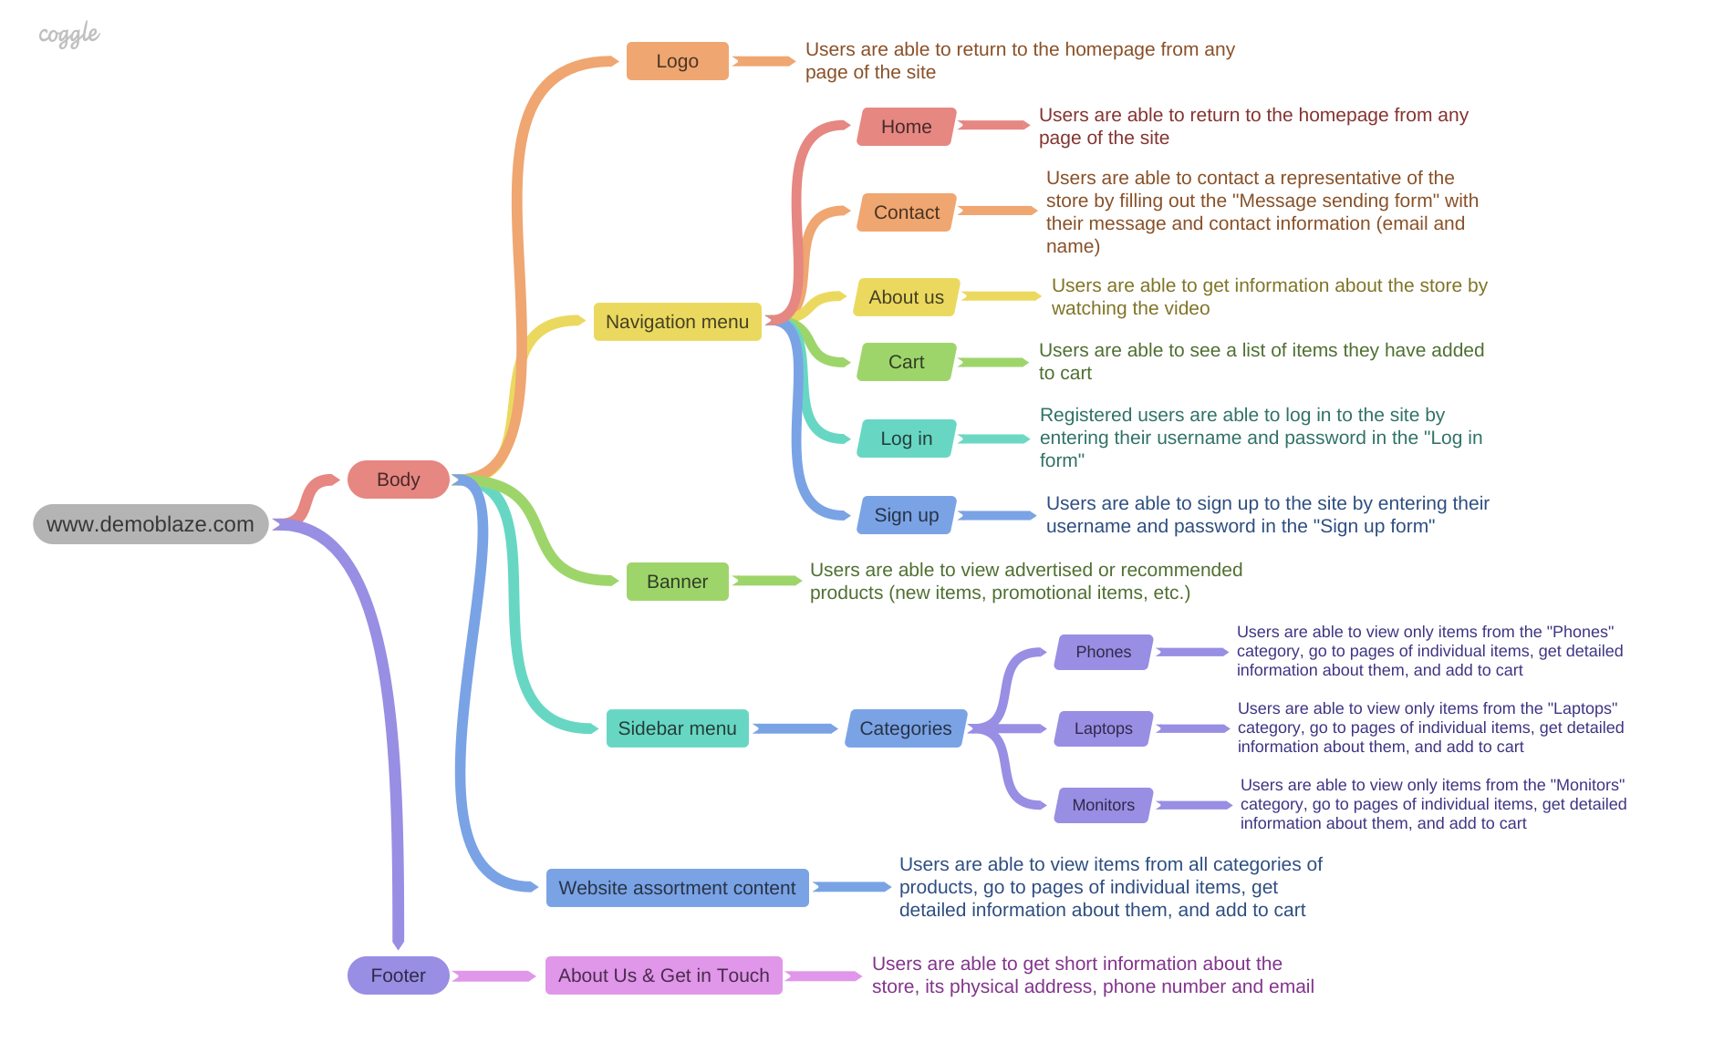](https://drive.google.com/file/d/1U6ViIFrT5ZSfCRqHneBVg0wj-rbR76fn/view?usp=share_link)

<https://drive.google.com/file/d/1U6ViIFrT5ZSfCRqHneBVg0wj-rbR76fn/view?usp=share_link>

**2.1. Features to be tested**

2.1.1. Sign In and Log In features

2.1.2. Shopping Cart

2.1.3. About Us

2.1.4. Contact

2.1.5. Home button and Logo button

2.1.6. Banner

2.1.7. Filtering by categories

2.1.8. Product page

2.1.9. Information in footer

**2.2. Features not to be tested**

2.2.1. The service should allow user order delivery

2.2.2. The service should allow users to pay for products on the site

**3. Test Strategy**

The project uses an agile approach with weekly iterations. At the end of each week, the tasks identified for that iteration will be done and reviewed by team members.

Without knowing the internal structure or program source code, the “[www.demoblaze.com](https://www.demoblaze.com/index.html)” will be tested using a “black box” approach.

**3.1 Entry Criteria**

The Testing Team may suspend partial or full-testing activities on a given build if any of the following occurs:

– There is a fault with a feature that prevents its testing.

– A severe problem has occurred that does not allow testing to continue.

**3.2 Test Methods**

Testing is the process of attempting to find discrepancies between the program and its functional specifications/requirements. The goal is to ensure that all functions of the “[www.demoblaze.com](https://www.demoblaze.com/index.html)” applications work correctly.

**Manual functional testing** – is considered the primary method of application testing.

**3.3 Test Types**

3.3.1.**Functional testing**. Functional testing ensures that the whole software product works according to the requirements and that no significant errors appear in the application. Functional testing is the most substantial part of software testing. It involves checking different aspects of the system. A software product must pass all the planned tests. Only in this case, its quality can be assured.

3.3.2.**GUI Testing** is performed by interacting with the software under test via the graphical user interface. Verifies that user interface meets design guidelines, and ensures UI controls, and input fields work as expected.

3.3.3.**Compatibility Testing**. Compatibility Testing determines whether the product operates correctly in configurations with various operating systems, and browsers.

**3.4 Test Levels**

3.4.1. **Smoke Test** is performed to quickly assess the product’s readiness for further, more deep, and thorough testing. It includes testing “[www.demoblaze.com](https://www.demoblaze.com/index.html)” applications’ major functions on the most often used and, consequently, the most important server/client configuration.

3.4.2. **Critical Path Test** will be performed after the Smoke Test is passed. The goal of the Critical Path Test is to find bugs that could affect the major functionality of the application that is most important for the product users. Critical Path Test will be performed manually.

3.4.3 **Extended Test**’s goal is to find bugs related to the non-typical but still possible and likely usage scenarios (e.g., entering the incorrect data into the fields, boundary testing, and so on). Extended tests will be performed according to test cases.

**4. The criteria of quality**

The product should operate following the requirements and the functional specification (if present). The product should not contain critical and blocking defects in the final version of the project.

**5. Testing Process Risks**

The next issues may influence testing works:

– Changes and modifications of the software product that were not planned and discussed with the test team beforehand;

– Changes in the software requirements that were not discussed with the test team beforehand;

– Delays in correcting/fixing errors;

– Delays in delivering new builds to the test team.

**6. Testing Tools**

– Project structure – **Mind Map**

– Test case creation – **Microsoft Excel**

– Test case tracking – **Microsoft Excel**

– Test case execution – **Manual**

– Test case management – **Microsoft Excel**

– Defect management – **Microsoft Word**

– Test Summary Report – **PowerPoint**

– Checklist creating – **Microsoft Excel**

**7. Environmental Needs**

| OS | Windows 10 Pro 22H2 x64 | | | macOS 13.0 Ventura |
| --- | --- | --- | --- | --- |
| Browser | Google Chrome 107.0.5304.87 | Mozilla Firefox 106.0.5 | Opera 92.0.4561.43 | Safari 16.1 |

| Mobile Platform | iOS 16.1 | Android 13 |
| --- | --- | --- |
| Browser | Safari 16.1 | Google Chrome |

**8. Test Team Expectations**

The test team must be provided with valid, updated documents during the whole testing process.

All the required equipment, instruments, devices, and software must be acquired and prepared before testing. All show-stopping errors must be corrected as soon as possible. Release notes should be added to each software release to the test team.

The note must explain which elements, functions, and features were added to the program and how these additions affect the software. The developers should correct all the errors in the software modules before releasing a new version.

**9. Criteria for Starting and Ending Testing**

**9.1. Entry criteria**

– Approved test plan and/or test strategy

– A build of the website is deployed to the required environment

– All testers are familiar with the goals of the project

– Checklists/test cases are created and prioritized

**9.2. Exit criteria**

– All defined test cases are passed and marked “Pass” status

– A version is considered ready for release in case of being based on the results of testing there are no defects with priority High and Medium. Also with severity Blocker and Critical and no more than 5% defects with Major and 5% Minor or Trivial severity in a not-fixed state

**10. Responsibilities of Test Team Members**

**Testing Project Manager**

– Managing the whole testing process.

– Providing all the needed resources for the testing activities.

**QA Lead**

– Collecting and learning the requirements.

– Validation of the documentation.

– Planning the testing works.

– Monitoring the testing activities, making sure that the works are performed according to the plan.

– Reporting about the progress, number, and severity of the found errors.

**Test Engineer**

– QA process/logging found errors in the approved bug tracking system.

**11. Test Deliverables**

1. Software Requirements Specification

2. Test Plan

3. Test case specifications

4. Requirement Traceability Matrix

5. Bug report

6. Test summary report

**12. Schedule**

| **Task Name** | **Start** | **Finish** | **Comments** |
| --- | --- | --- | --- |
| Exploring the testing product and Mind Map creating | 25.10.2022 | 26.10.2022 | Completed |
| Writing requirements | 27.10.2022 | 29.10.2022 | Completed |
| Requirement Analysis | 30.10.2022 | 30.10.2022 | Completed |
| Test Plan writing | 31.10.2022 | 31.10.2022 | Completed |
| Requirement Traceability | 31.10.2022 | 01.11.2022 | Completed |
| Matrix creation | 01.11.2022 | 01.11.2022 | Completed |
| Test cases creation | 01.11.2022 | 03.11.2022 | In process |
| Test execution | 0.11.2022 | 05.11.2022 | In process |
| Bug reports writing | 05.11.2022 | 05.11.2022 | In process |
| Test closure | 06.11.2022 | 06.11.2022 | Not completed |
| Test Summary report writing | 07.11.2022 | 07.11.2022 | Not completed |
| Test Result Presentation | 08.11.2022 | 08.11.2022 | Not completed |

**13. Risks and Contingencies**

Legend:

**VH** – Very High;

**H** – High;

**M** – Medium;

**L** - Low

| **Risk** | **Probability** | **Impact** | **Actions** |
| --- | --- | --- | --- |
| Problems in the test equipment. Breakdown of computer hardware or failures on the server side of the project. This can lead to a significant slowdown in project activities. | L | M | Availability of spare equipment, which will be provided if necessary. |
| The testing team consists of inexperienced workers; this can lead to the omission of different bugs. | VH | VH | Experienced people: RM or another tester will help the testing team resolve any problems in urgent cases. |
| Different types of leave (sickness or vacation) of any Member of the testing team can lead to an additional workload on other project participants. | H | M | RM can provide a project for an additional temporary person to work with during the absence of a team member. |
| Force majeure circumstances that may lead to the de-energization of the workplace, which will lead to the suspension of work on the project | L | M | The presence of another room in the absence of electricity at the permanent workplace |
| Changes (decreases) to the budget or resources for the project | L | H | To think over and register all the necessary resources and their estimated amount. For example, you can specify all resources with a small margin |
| Company devices do not match the requested devices for testing from the customer | L | M | In advance to announce to the customer what devices the company has, and, in case of a critical need for those or other devices to include their purchase in the budget |
| Unstable Internet access | H | VH | It is quite difficult to control an unstable Internet connection, but before starting the project, you need to make sure that there are no big failures in Internet providers |
| Localization of all project participants | M | M | When including participants in the project, it is necessary to correctly take into account the localization of each one. The team should consist of people who work in approximately the same time frame for fast and high-quality communication |
| Test environment prepared too late | L | M | Constant communication with developers |
| The project is dominated by blocking and critical bugs | L | L | If the main number of bugs in the project is blocking and critical, you need to contact the PM or the development team head, as well as regularly monitor whether the bugs found are taken to work |
| Customer changes requirements too often, or at the last minute | L | H | Discuss with the customer all the necessary functions, design details, the capabilities of this site in detail. Mark strict time limits when the customer can still make changes, constantly communicate with the customer, and show the work done |

**14. Responsibilities**

| Andriy O. | Software Requirements Specification  Test Plan  Test case specifications  Requirement Traceability Matrix  Bug report  Test summary report |
| --- | --- |
| Olena Y. | Software Requirements Specification  Test Plan  Test case specifications  Requirement Traceability Matrix  Bug report  Test summary report |
| Dmytro S. | Software Requirements Specification  Test Plan  Test case specifications  Requirement Traceability Matrix  Bug report  Test summary report |
| Mariana M. | Software Requirements Specification  Test Plan  Test case specifications  Requirement Traceability Matrix  Bug report  Test summary report |
| Volodymyr A. | Software Requirements Specification  Test Plan  Test case specifications  Requirement Traceability Matrix  Bug report  Test summary report |

**15. Approvals**

|  | Name | Position | Signature | Date |
| --- | --- | --- | --- | --- |
| 1. | _______________ | _______________ | _______________ | ____.____.________ |
| 2. | _______________ | _______________ | _______________ | ____.____.________ |
| 3. | _______________ | _______________ | _______________ | ____.____.________ |
| 4. | _______________ | _______________ | _______________ | ____.____.________ |